

**Petal Power**

**GFWC Joppatowne Woman's Club, Inc.**

**P.O Box 382 Joppa, MD 21085-4502**

**September, 2013**

**President’s Message Diane Raycob**

**410-893-7534**

I hope that during the past summer months you and your families were blessed with the absence of illness and that you had the opportunity to take time from your normal duties to enjoy yourselves.

I know that you will all agree with me that summer has gone by all too fast. But this is an old story and one that we should be used to. The future looks so far ahead and then in the blink of an eye it is miles behind us. So it appears that the most natural thing to do, in the absence of a stand-still time machine, is to utilize our free time (some of us have very little of it) as best we can. Those precious minutes we waste thinking of yesteryear or waiting for the opportune time can never be regained. If we can recondition ourselves to take advantage of today, then we can be better equipped to spend tomorrow with greater satisfaction.

So plant that rose garden, walk an extra few blocks, volunteer to help out, and bring a neighbor to our next general meeting. Our club still needs chairmen for the Arts, Conservation, and Public Issues departments. Let’s be active today and not wait for tomorrow to start.

**Diane**

It's difficult to think anything but pleasant thoughts while eating a homegrown tomato.-  Lewis Grizzard

**

**September Birthdays**

Carol Metzger 8 Barbara Knapp 13

Karen Conte 9

Maureen Cornett 10 Ursula Pierce 22

Barbara Ledford 10 Dee Ketelhut 25

MC900445200[1]

**Hospitality Madeline Murphy**

**410-569-0477**

The dinner meals have increased to $25.00. Please call in your dinner order by Saturday before the Thursday meeting. If you have to cancel, please do not call the restaurant. Call **Madeleine.**  
Here are the Sept 12th dinners: Pork Chop, Beer-battered Cod, or Plain chicken  
Hostesses: **Madeleine Murphy** 410-569-0477 or **Dee Ketelhut** 410-679-3616

Looking ahead, the dinners for October 10th are: Chicken Parmesan, Stuffed Flounder, or Plain Chicken. The hostesses for October will be **Rosemary Sebula** and **Rose Marie Vaccaro**.  
Thanks.

**MC900190661[1]**

**Membership**

We initiated a new member at our June meeting. Her name is **Leah Clague** and she lives with her husband in Joppa. Please take a moment at our next meeting to introduce yourself to her. May she find many friendships and memories within our club!

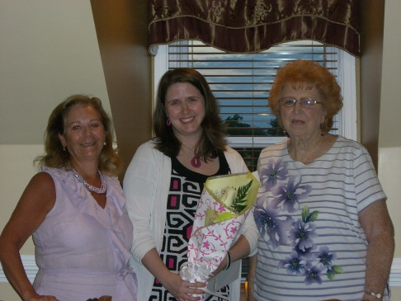

President Diane, new initiate Leah, & sponsor Betty

Also, like last year, we will hold two “workshops” at Boscov’s to let the public know a little more about our group and what we do. The dates will be Monday, September 16 at 10 a.m. and Wednesday, September 25 at 6 p.m. Please let **Diane** know if you would like to meet us there to help spread the word!

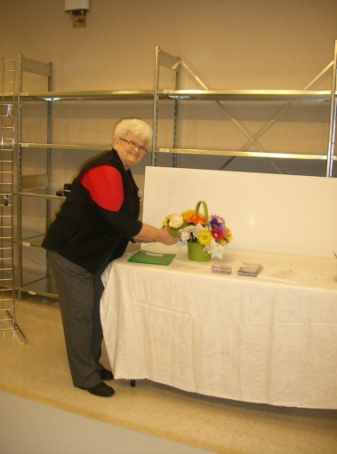

Dottie preparing the presentation, 2012

**Second Vice President/Programs Betty Manthei**

**410-679-4653**

Got speakers? Got ideas for programs? We are always looking for interesting topics for our monthly general meetings. Have you heard a great speaker that you think would be of interest to your fellow clubwomen? Please send your ideas to me.

Our September meeting is a short presentation of how our club works from the local perspective to the global one. If you have any particular points you’d like to be covered concerning JWC, MFWC, or GFWC, let **Diane** know before the meeting.

MC900363474[1]

**Corresponding Secretary Rosemarie Vaccaro**

**443-373-5404**

Thank-you, thank-you to **Rosemarie** for taking over this position. **Barbara Knapp** is very busy taking care of her mom and we wish both of them the very best.

**Rosemarie** is charged with sending cards and notes of congratulations, illness and sympathy to members and their families. As directed, she will also handle general correspondence for the JWC. Let's make it a good year with lots of happy occasions for cards and notes.

C:\Users\Owner\AppData\Local\Microsoft\Windows\Temporary Internet Files\Content.IE5\MELZT6UM\MC900410789[1].wmf

**Treasurer Maureen Cornett**

**410-676-4428**

**Article IV, Section 2** of our Bylaws reads:

Annual dues shall be forty-five dollars ($45.00). All dues are payable at the June meeting and are delinquent at the September meeting. New and reinstated member dues shall be prorated on a monthly basis of $4.50. The Treasurer shall notify the Membership Chairman of those members whose dues are in arrears and after the October general meeting; such members shall automatically be dropped from the roll.

*Please pay your dues if you have not already done so. Thanks!*

MC900441886[1]

**Arts** (no chair at this time)

Members: **Dottie Bishoff, Mary Ann Bittner, Ellie Kimlicko,** and **Barbara Ledford**

We had a wonderful outing in Havre de Grace visiting an antique store and then having lunch at Laurapinn over the summer.

Our next meeting will be held on Monday, October14 at 12 p.m. at **Diane’s** house. We will discuss shirts for the club members and another “Field trip” to Havre de Grace again.

The 48th annual Bel Air Arts Festival will be held Sunday, September 15, 10 a.m. -5 p.m. It’s free admission, rain or shine. There will be more than 350 artists, photographers and juried craftsmen from Maryland and eight other states. There will be live entertainment and plenty of food and drink.



**Conservation** (no chair at this time)

Members: **Dottie Bishoff, Maureen Cornett, Claire Geis** and **Carol Metzger**

Flush tax - $15.00 a quarter or $60 a year.

Rain tax - $12.50 (10% of $125.00 fee)

**Bay-Wise Maryland Yardstick – FREE!**

By changing a few simple landscape practices**,** you and your family can be a Bay-Wise Home. Earn 36 inches (or more) on your yardstick for the following practices:

* control of storm water runoff
* encourage wildlife
* protest the waterfront
* mow properly/water efficiently
* manage yard pests with integrated pest management (IPM)
* mulch appropriately/recycle yard waste
* fertilize wisely
* plant wisely

Remember all water runs downstream to the bay. Help save the bay. **Be Bay-Wise!**

On another note, keep bringing in the pop tops and items for the animal shelter. Car pool as often as you can.



**Education Karen Conte & Barbara Ledford**

**410-569-3902 410-679-1166**

Members: **Barbara Albers, Dottie Bishoff, Cathy Bowden, Ruth Cameron, Dee Martin,** and **Rosemary Sebula**

The second scholarship recipient finally contacted **Barbara L.** and she was able to send the check to her college.

We will be in contact soon with Mrs. Constantine at the Joppatowne Elementary to resume our reading program.

We received a thank-you note from the Joppatowne HS HOBY recipient which will be read aloud at our next general meeting.

September is Library Card Sign-up Month. so if you don’t have one, get one!

**Home Life Barbara Albers & Sue Tyber**

**410-679-5260 410-679-8963**

Members: **Dottie Bishoff, Ruth Cameron, Reno Eitel, Ellie Kimlicko, Barbara Ledford, Betty Manthei, Dee Martin, Jeanette Petnic, Ursula Pierce, Rosemary Sebula,** and **Rose Marie Vaccaro**

Thanks to all the ladies that participated in the clothing donation to Harford Family House for their career day. We received a lovely thank you letter from them. Eight women donated 53 pieces of clothing. We will probably repeat this project next year.

               This committee is again sponsoring a small group of us to participate in the “Walk to cure Alzheimer’s.” Those who aren’t going to walk can also participate by writing a check out to Alzheimer’s Association, and give them to me or to the person you chose to sponsor at the September general meeting. Those participating are: **Barbara Albers** (non-walking captain), **Diane Raycob, Jeanette Petnic, Dottie Bishoff, Barbara Ledford, and Cathie Bowden**. Fifty per-cent of those over 85 develop some form of dementia (mostly women), so let’s support the cure!!!  This is tax deductible.

C:\Users\Owner\AppData\Local\Microsoft\Windows\Temporary Internet Files\Content.IE5\I2CTHOBB\MC900391282[1].wmf

               Please check your closet for some lightly used handbags that you no longer use. Bring them to the September general meeting. I will donate them to Harford Family House for their annual handbag sale at the Bel Air Armory on Main Street. It will be held Sept. 19th-20th-and 21st.Some of our ladies attended last year and enjoyed it .I can also obtain tax receipts so you can deduct this from your taxes.

               Health Tip: Dark chocolate can increase cognitive function, so eat up (in small amounts, of course). Who knew? (Sun Paper)

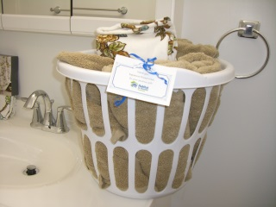

Basket donated to new Habitat for Humanity Bel Air home

**International Outreach Mindy Kretschmer 410-638-5449**

Members: **Dottie Bishoff, Madeline Murphy, Mary Reynolds,** and **Rose Marie Vaccaro**

As mentioned in the *Maryland Clubwoman,* World Polio Day is October 24th. You can help eradicate this disease by donating $20 to the United Nations Foundation’s Shot@Life Campaign.

Host a World Food Day dinner on October 16th or sometime this month that fosters a conversation about where your food comes from, who cultivates it, and how you can take personal actions that will make the food system more just and sustainable.

**Public Issues** (no chairman at this time)

Members: **Dottie Bishoff, Reno Eitel, Betty Manthei,** and **Betty Meidinger**

*Projects discussed for possible implementation this club year are*:  
Operation Welcome Home - Dottie suggested we work with this organization to see if we could meet veterans returning from overseas at BWI 1 or 2 times a year.  Perhaps there are other needs we could fulfill.    
Basket for Sheriff's Office or Fire Department - A breakfast or lunch basket might be offered as an appreciation of service to the community.  Perhaps we contact Dunkin Donuts, Mars, or Redner's and ask for a donation of coffee and donuts for breakfast.

*Projects that could continue:*  
Visits to the Perry Point VA Medical Center with personal grooming items, books, playing cards, etc.  and Valentines for the veterans.  Veterans Day is November 11.    
Club members, please remember to report the dollar amount of donations of used clothing and household items to organizations supporting our veterans. Let **Diane** know each time you do this.  
Collection of used cell phones that can be taken to Exit Realtors, 2105 Laurel Bush Rd. (410 670-9100) who will forward them for refurbishment and shipment to overseas troops.

**Ways & Means Dottie Bishoff 443-402-1421**

Members: **Barbara Albers, Cathy Bowden, Karen Conte, Reno Eitel, Claire Geis, Barbara Ledford, Betty Manthei, Betty Meidinger, Madeleine Murphy, Jeanette Petnic** and **Rose Marie Vaccaro**

Hello ladies, are you enjoying this nice weather?

Summer has come and gone and we will be starting our fundraising for the coming year.

* At our last committee meeting it was decided to do the Kindle Fire HD for our Christmas raffle. Tickets will be ready at our October general meeting.
* In January, we will have tickets ready for our annual tea which will be held again at the Richlin Ballroom the first Saturday in May. Some changes have been made to the menu and all suggestions have been considered.
* The "Pot of Gold” was voted on again as a fundraiser for March.
* We will have Betty Meidinger's 50/50 board again at all the meetings. That is a big help towards our budget.
* We will probably be doing the Christmas wrapping at Boscov's again.

Bus trips don't seem to be going well, so if anyone has any ideas for fundraisers please let me know. Let’s have more volunteers come forward this year.

All my best,

Dottie

**Two Sweet Easy Recipes**

EASY FUDGE RECIPE

1- can eagle condensed milk

1 1/2 bags chocolate chips (11.5 oz.bags)

1 cup chopped walnuts (optional)

Mix ingredients in microwavable bowl. Melt until creamy, pour into 8x8 baking dish.Cool for 2 hours, then serve.

EASY PINEAPPLE CAKE

2 c. all purpose flour

1 ½ c. sugar

2 tsp. baking soda

1 c. coconut (optional)

2 eggs, slightly beaten

1 tsp. vanilla extract

1 20 oz. can crushed pineapple

**For the frosting:**

3 c. powdered sugar

1 tsp. vanilla extract

¼ c. nonfat milk

Preheat oven to 350 degrees. Coat a 9 x 13 pan with non-stick cooking spray.

Combine flour, sugar, baking soda, and coconut (if using).

Add eggs and vanilla, and stir in crushed pineapple.

Pour into prepared pan and bake 30-40 minutes, until a toothpick inserted in the middle comes out clean.

For the frosting, mix powdered sugar, vanilla, and milk into a large bowl to desired consistency. Add more sugar or more milk as desired. If you want a coconut flavor, substitute coconut extract for the vanilla, and sprinkle some coconut on top.

**Dates to Remember**

September 12 – General meeting, 7 p.m. Williamsburg Inn. On agenda – reports from Auditand Budget committees

September 16 (10 a.m.) & 25 (6 p.m.) Workshops at Boscov’s

September 17 – MFWC State Board of Directors Meeting, 10 a.m., Chesapeake Inn, Chesapeake City

September 25 – Deadline for Oct. 3 district meeting reservation. Give to **Barbara Ledford.**

September 26 – JWC Board meeting, 7 p.m., __________________’s home

October 3 – MFWC Baltimore District board meeting, 10 a.m. Williamsburg Inn Make reservations by September 25.

October 5 – Walk to End Alzheimer’s

October 10 - General meeting, 7 p.m. Williamsburg Inn

October 14 – Art department meeting, 12 noon, Diane’s house

October 22 – Friends Helping friends, Boscov’s, 1:30-6 p.m.

October 24 - JWC Board meeting, 7 p.m., __________________’s home